

fIRST SIMULATION PROJECT

Alberto Javier Pelayo Brambila – A01636406



28 de septiembre de 2021

Control engineering

**First Simulation Project. Control engineering.**

**Part 1. Select some problems and solve. 75 points MAX. The parameters for this section are:**

**𝒂=𝐵𝑖𝑟𝑡ℎ 𝐷𝑎𝑦, 𝒃=𝐵𝑖𝑟𝑡ℎ 𝑀𝑜𝑛𝑡ℎ and 𝒄=𝑏+1**

**(a=19, b=8, c=9)**

**System 1. (15p)**

Getting the transfer function



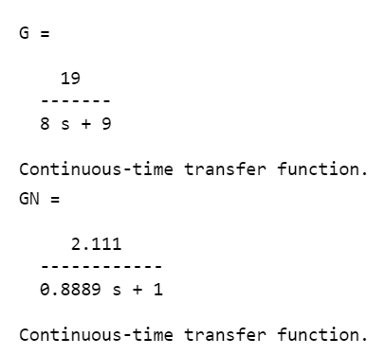

First, must normalize the function





**1. Characterization of the system in open loop.** The final value, settling time and, if necessary, damping factor, Natural frequency and Damped Natural Frequency. Assume the input u(t)=b.

**1.1 The final value**

The input u(t)=b=8

Then the final value is

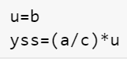



**1.2 Settling time**

For calculate the settling time, we need to obtain T, and the tss is 5 times T

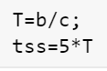



Simulating the model with the input u(t) gives the next graph, in this graph qe can see the correct final value yss and the tss

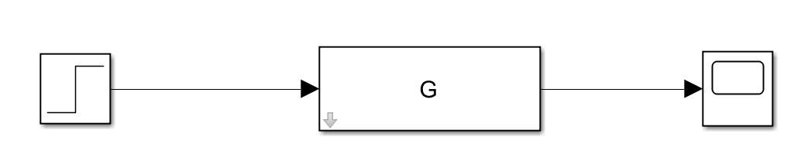

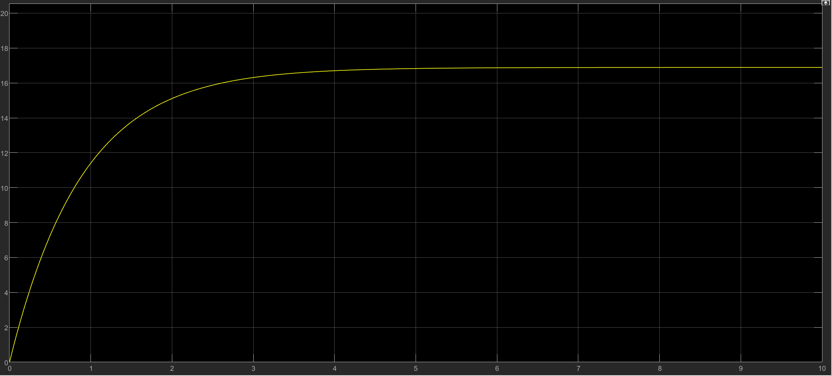

**2. Characterization of the system.** The final value in closed loop with a control gain K=a and a reference r(t)=c.

For the system in close loop, we know the value of the control gain K=19 is the same as a and reference r=6

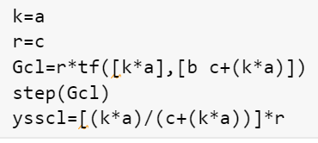

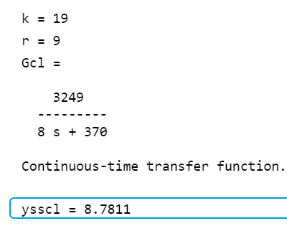

Simulating the system in close loop, we obtain

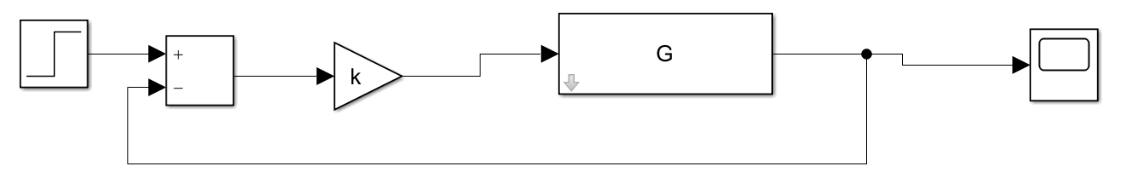

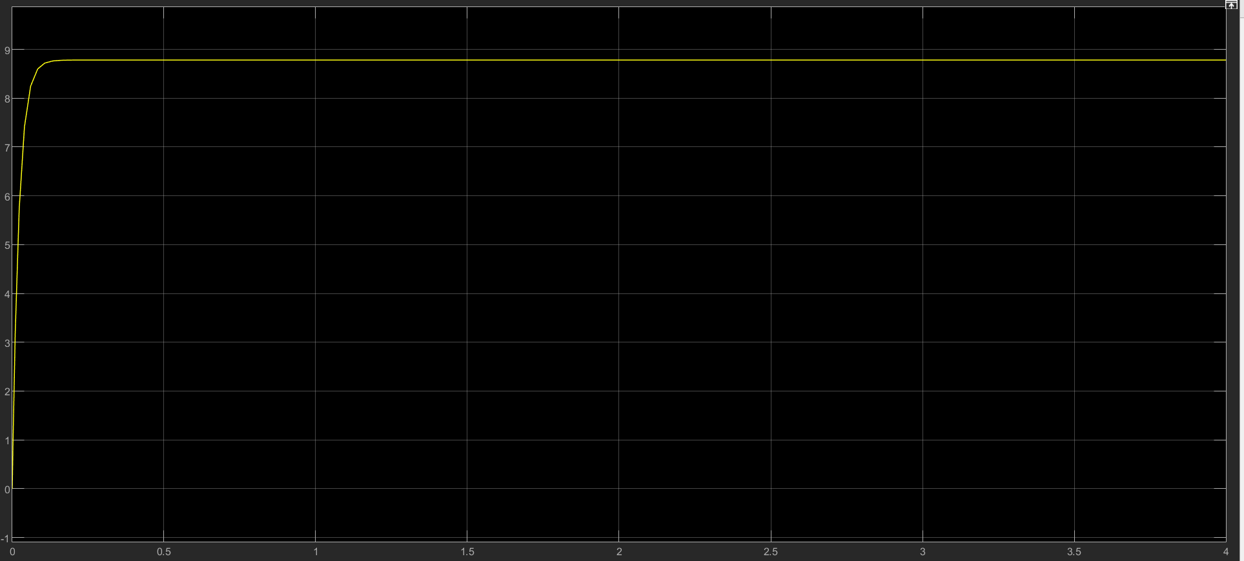

As we can see in the graph the value for yss in close loop is correct.

**3.Gain range for stability.** The set of gains for which the system is stable in closed loop.

With the function Sisotool Mathlab, we can obtain that the system will never be unstable, because k>0. The minimum value is



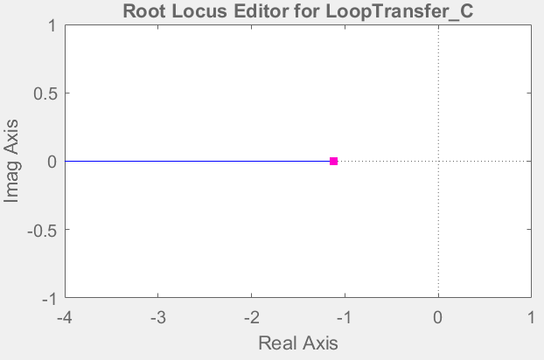

Gain range [4.7368e-05, +∞)

**System 2. (30p)**

Getting the transfer function



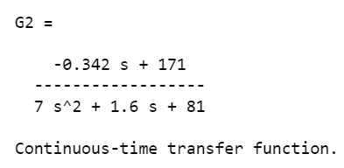

First, must normalize the function



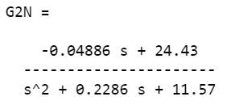

**1. Characterization of the system in open loop.** The final value, settling time and, if necessary, damping factor, Natural frequency and Damped Natural Frequency. Assume the input u(t)=b.

**1.1 The final value**

The input u(t)=b=8

Then the final value is





**1.2 Natural Frequency**

First, we need to obtain the Natural Frequency, with the square root of 11.57 obtained from G2N





With the natural frequency we can obtain delta





**1.3 Settling time**

For calculate the settling time, we have 2 criteria 2% and 5%









**1.4 Damped Natural Frequency**

For the Damped Natural Frequency, we need wn and delta obtained before.





Simulating this system we obtain

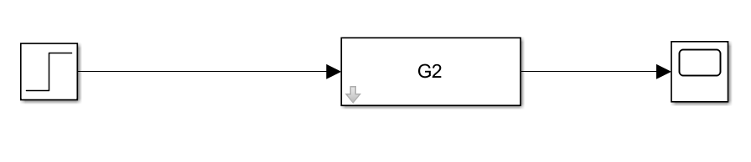

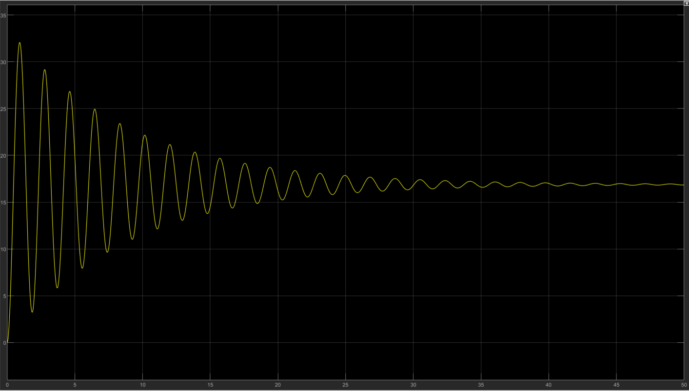

**2. Characterization of the system.** The final value in closed loop with a control gain K=a and a reference r(t)=c.

For the system in close loop, we know the value of the control gain K=19 is the same as a and reference r=6



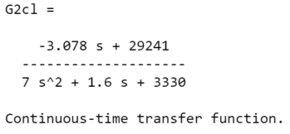





Simulating the system in close loop, we obtain

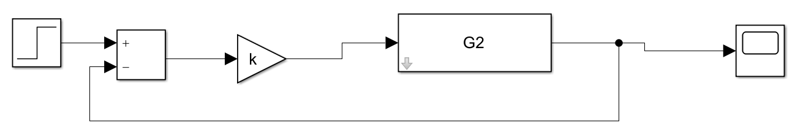

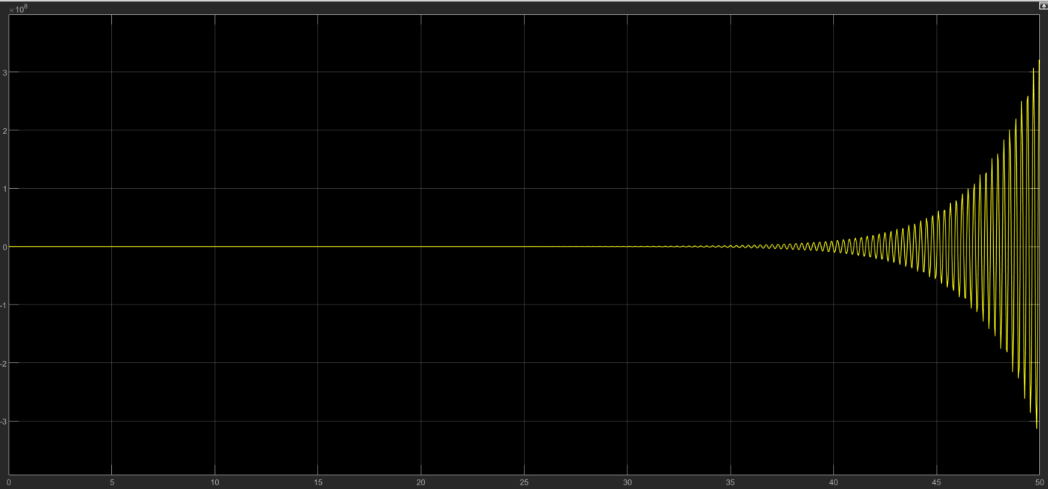

As we can see the model is unstable with the gain, the ranges must be limited to obtain stability.

**3.Gain range for stability.** The set of gains for which the system is stable in closed loop.

With the function Sisotool Mathlab. The minimum value is

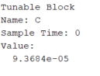

And the maximum value

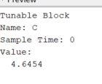

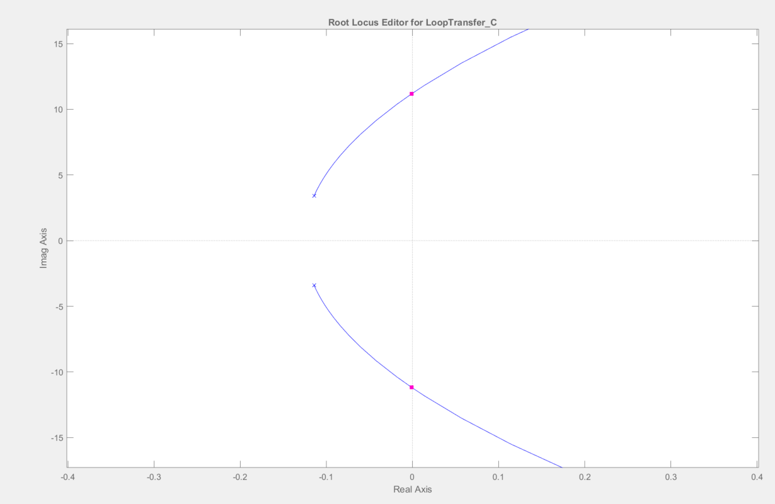

**System 3. (30p)**

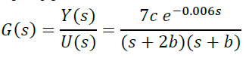

Getting the transfer function



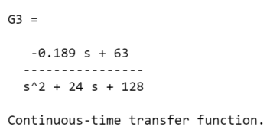

**1. Characterization of the system in open loop.** The final value, settling time and, if necessary, damping factor, Natural frequency and Damped Natural Frequency. Assume the input u(t)=b.

**1.1 The final value**

The input u(t)=b=8

Then the final value is





**1.2 Natural Frequency**

First, we need to obtain the Natural Frequency, with the square root of 11.57 obtained from G2N





With the natural frequency we can obtain delta





**1.3 Settling time**

For calculate the settling time, we have 2 criteria 2% and 5%









**1.4 Damped Natural Frequency**

For the Damped Natural Frequency, we need wn and delta obtained before. In this case is a overdamped case, because delta >1

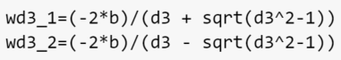





Simulating this system we obtain

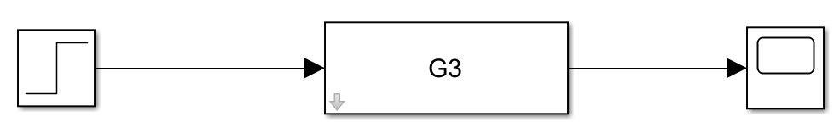

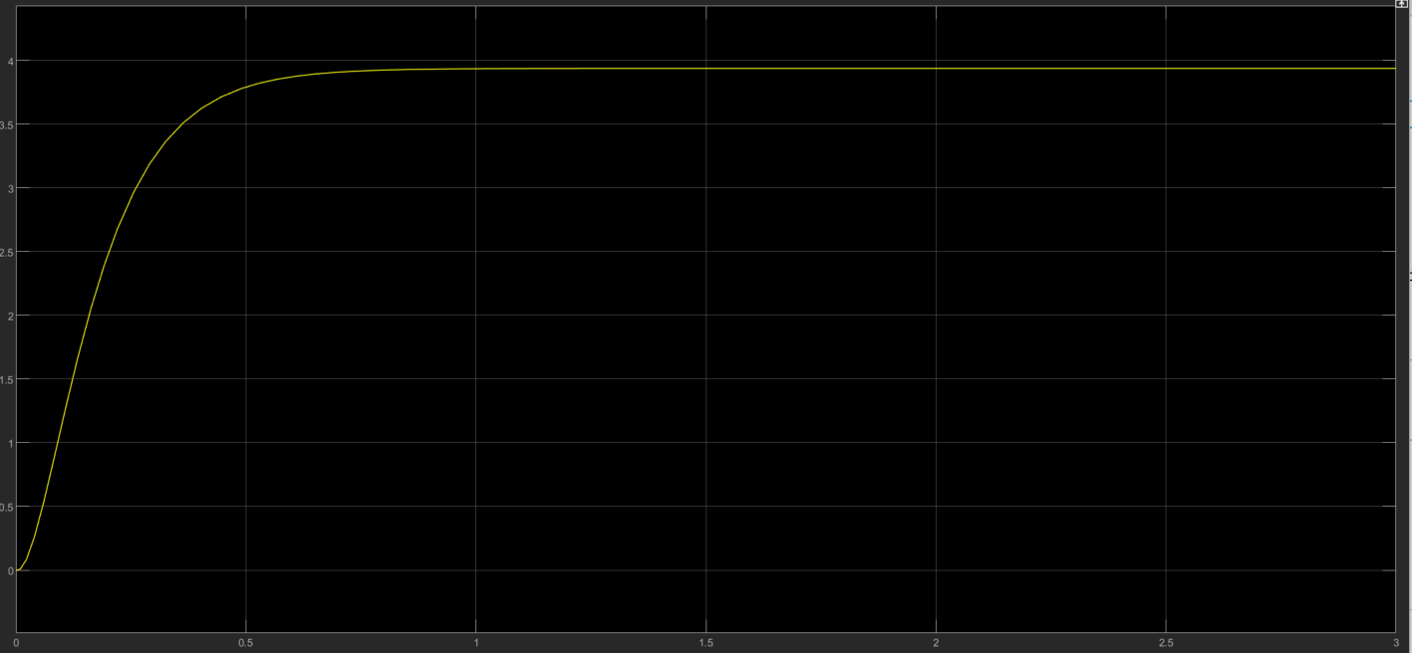

**2. Characterization of the system.** The final value in closed loop with a control gain K=a and a reference r(t)=c.

For the system in close loop, we know the value of the control gain K=19 is the same as a and reference r=6



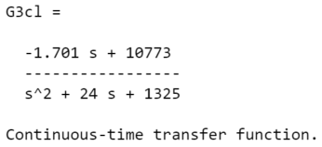



Simulating the system in close loop, we obtain

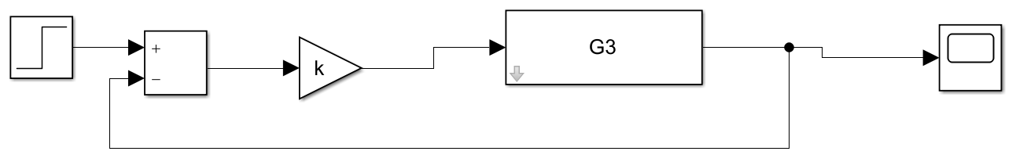

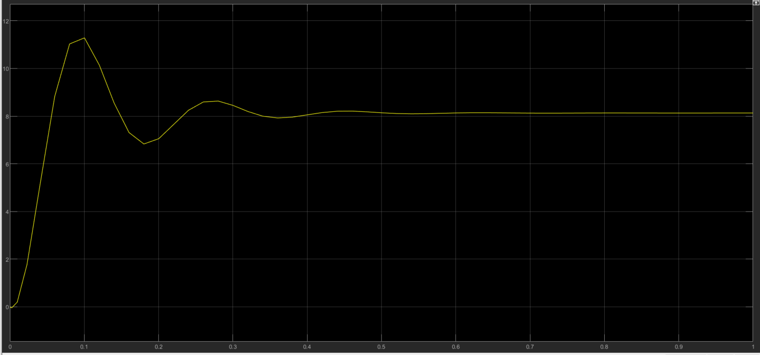

**3.Gain range for stability.** The set of gains for which the system is stable in closed loop.

With the function Sisotool Mathlab. The minimum value is

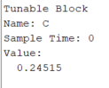

And the maximum value

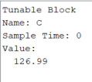

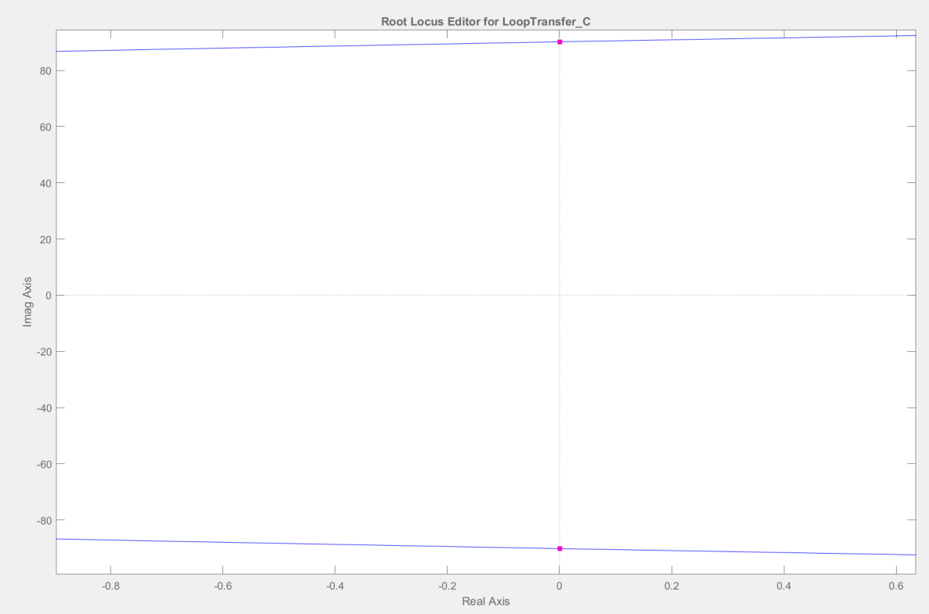

**Sistema 5. (25p)**

Consider the following system. The flow in the tank above is the input to the system (manipulated variable Qin). The parameters for this example are given in the Workspace file for this project, and individually assigned.

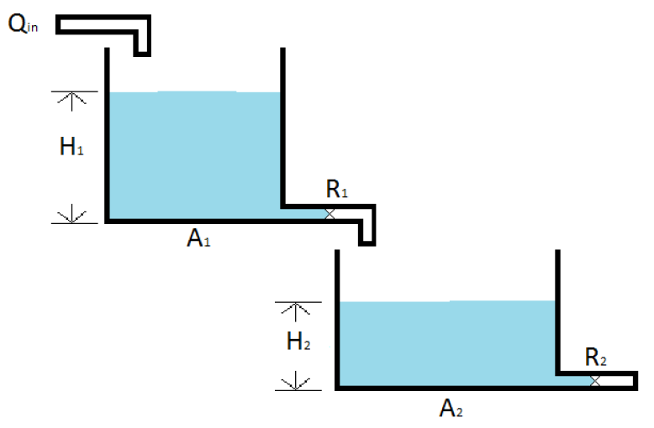

Parameters H1 and H2 can be the output of the system. Parameter H1max and H2max correspond to the real height of the tank and will be used on the final question. Finally, parameters A1, R1 and A2, R2 are the area and the resistance to the laminar flow of Tank 1 and Tank 2 respectively.

1. (6p, 3p each) Obtain the symbolic transfer function

a. H1(s)/Qin(s)

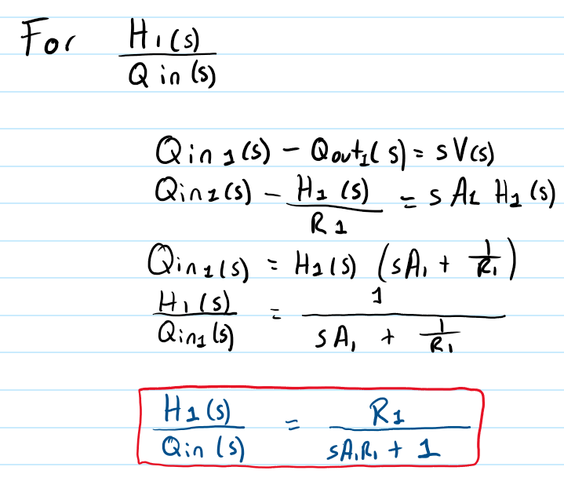

b. H2(s)/ Qin(s)

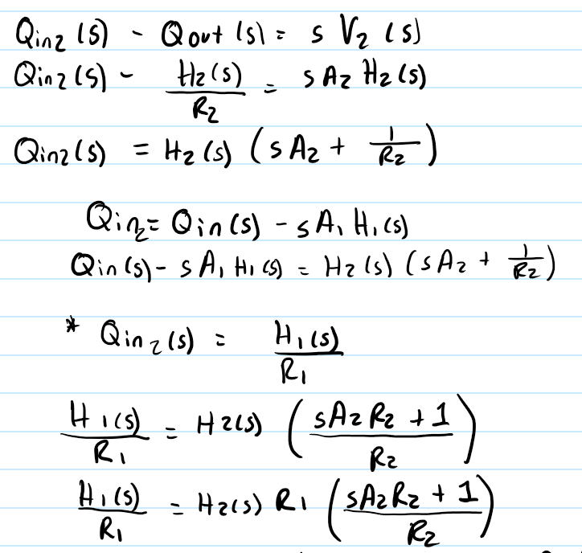

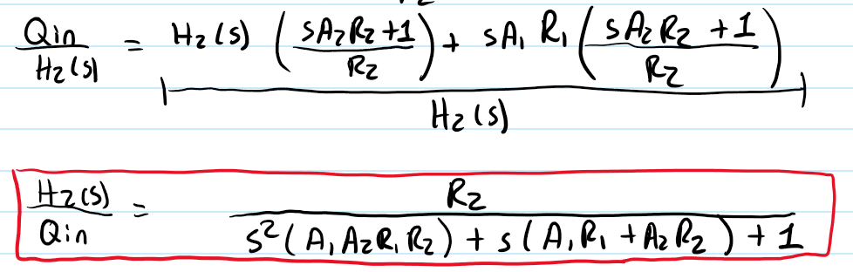

2. (4p, 2p each) Obtain the numeric transfer function with the parameters assigned to you.

a. H1(s)/Qin(s)

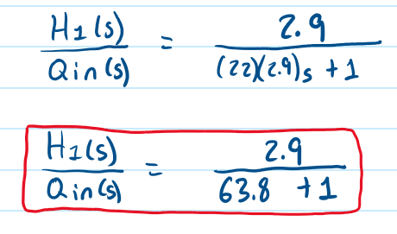



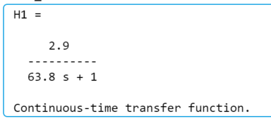

b. H2(s)/ Qin(s)

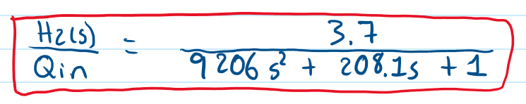



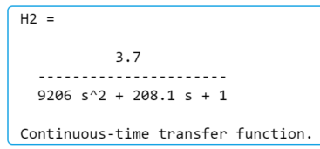

3. (5p) For H1(s)/Qin(s) Assume an input equal to the assigned variable Qin_1. Compute the final value of H1 and the settling time

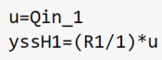



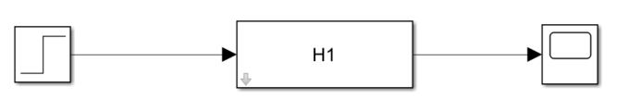

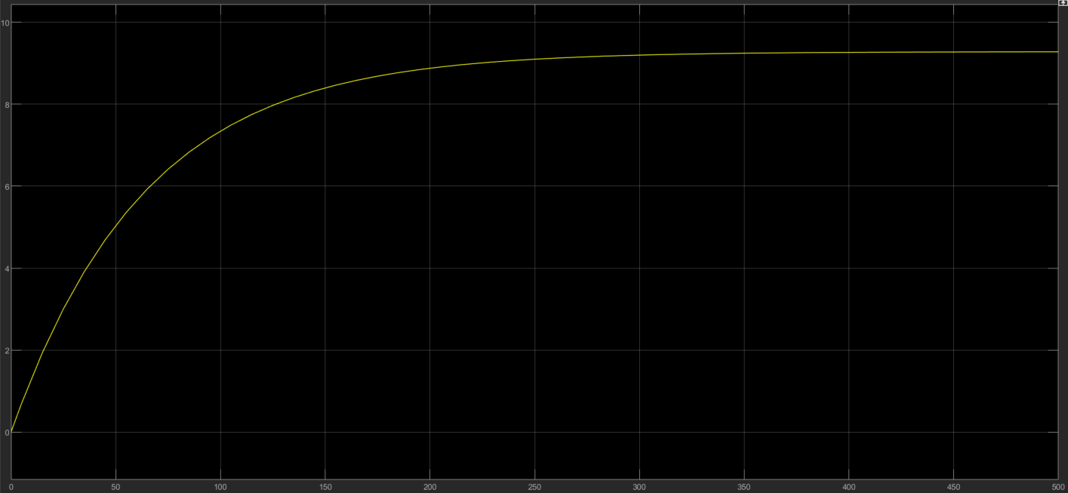

**4. (10p) For H2(s)/Qin(s)** Assume an input equal to the assigned variable Qin_2. Compute the final value of H2, the settling time, the natural frequency of the system, the damping factor and the damped natural frequency.

**4.1 Final Value**

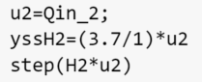



**4.2 Natural Frequency**

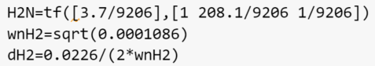

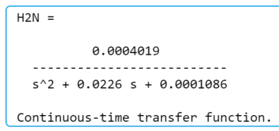

**4.3 Settling time**

